Functionality
You prepare the material cost estimate with quantity structure, on basis of data provided by Production Planning module. The cost estimate is a tool for planning non order-related costs and establishing prices for materials. It is used to calculate the cost of good manufactured and cost of good sold for each product unit.

Business Scenario

You want to calculate & save cost estimate for a new product 22000051 – 218w to be produced in plant 1200 since the beginning of May 2004. You can see the costing information, such as BOM, Routing, costing variances etc, and you can see the cost estimates in 3 view (1) itemization (2) cost component - primary split view (3) cost component – process view.

Requirements

Reqd from Production Planning
Quantity structure for the material was prepared by PP:
- Bill Of Material and rate routing for repetitive manufacturing
- Master Recipe for process manufacturing

- Reqd from Controlling
The following done by the CO:
- Procurement alternative were created
- Mixing Ratios were maintained

Menu Path | Accounting → Controlling → Product Cost Controlling → Material Costing → Cost Estimate with Quantity Structure → CK11N - Create
Transaction Code | CK11N

1. Double click on CK11N - Create.

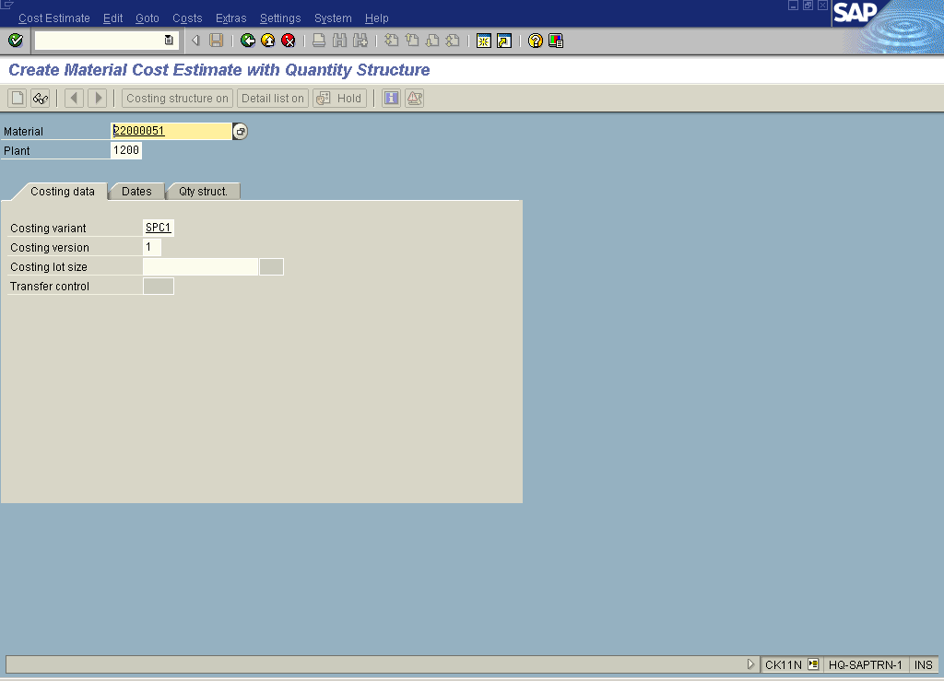

2. Update the following fields:

Field Name | Field Description | Values
Material | Code identifying a product or component | Example: 22000051
Plant | Code identifying the operational unit of the company where the material is manufactured and stored | Example: 1200
Costing variant | Costing variant, i.e. for Legal valuation. | Example: SPC1
Costing version | Costing version, i.e. for mix costing considering different production versions. | Example: 1

3. Click the Dates tab button.

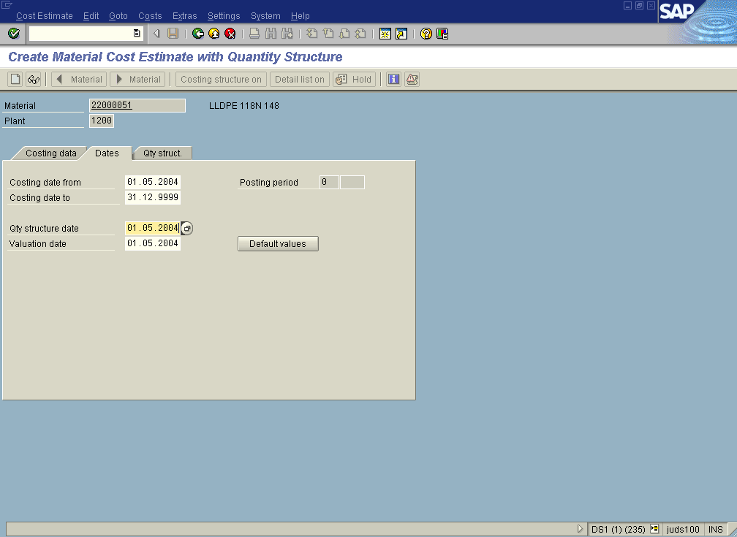
4. Update the following fields:
Field Name | Field Description | Values
Costing date from | Description of the Costing date from. | Example: 01.05.2004
Costing date to | Description of the Costing date to. | Example: 31.12.9999
Qty structure date | Description of the Qty structure date. | Example: 01.05.2004
Valuation date | Description of the Valuation date. | Example: 01.05.2004
Note: Alternatively you can press the Enter button or click the Default values button to copy the dates, as you prepare costing for the next period. If you would like to create cost estimate to be used since the current date you have to specify this current date in the ‘Costing date from’ field.
5. Click the Enter button.

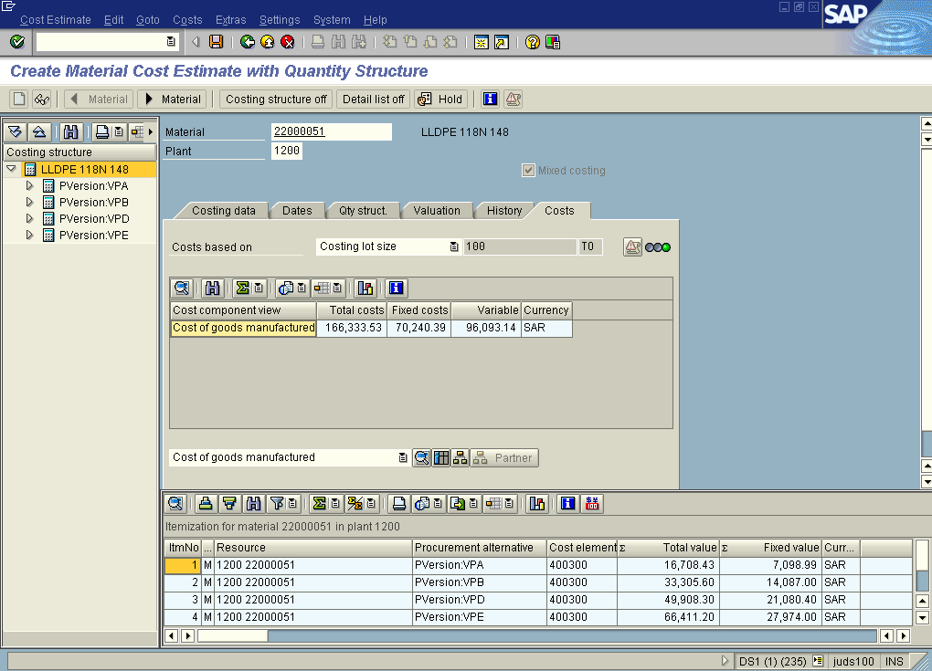

6. Click the Only materials / All items button.

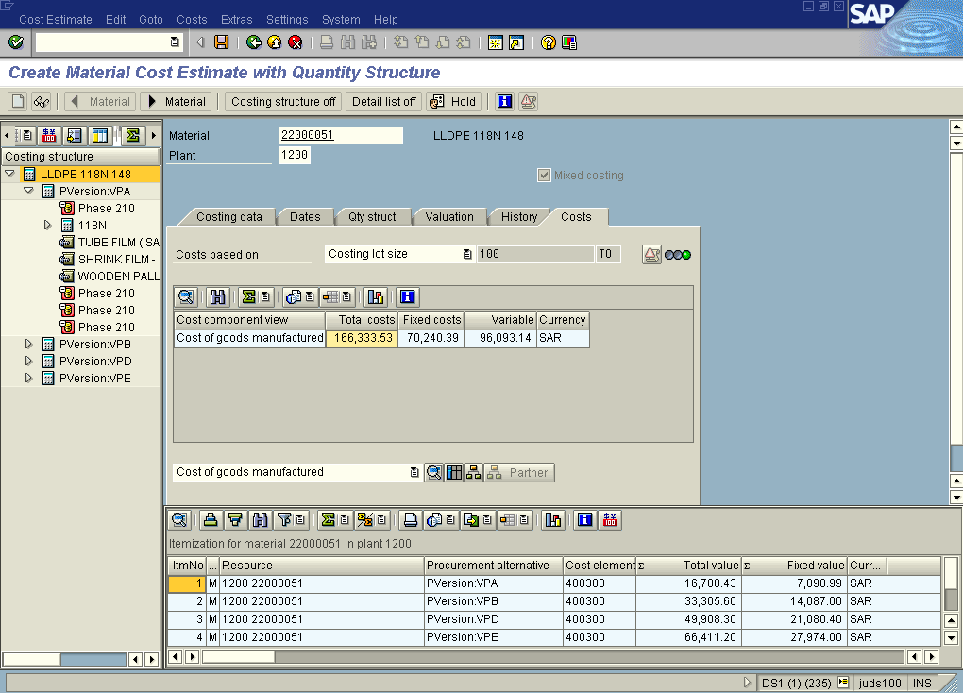

7. Click the Dates tab button.

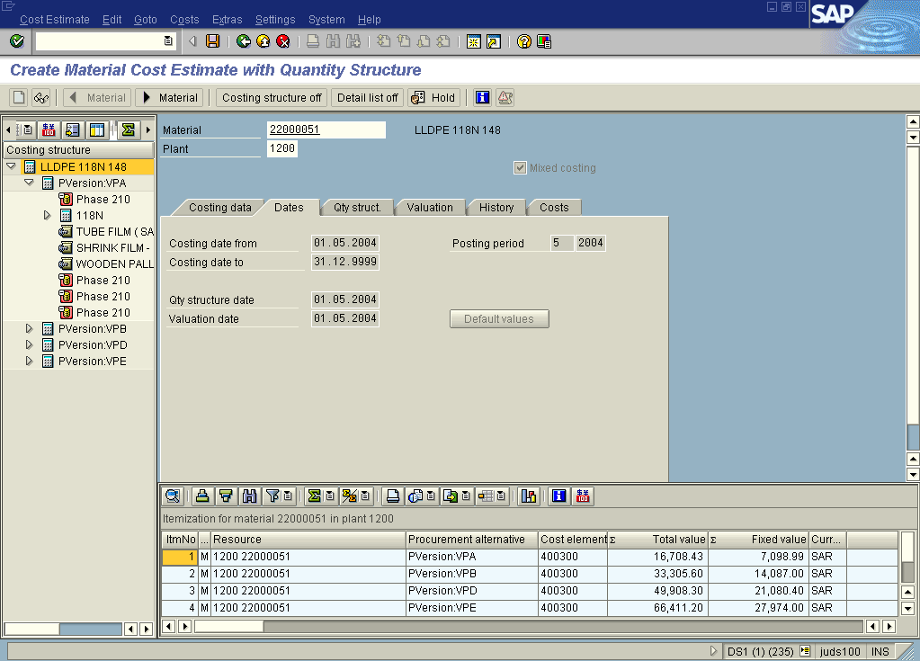

8. Click the Qty struct. tab button.

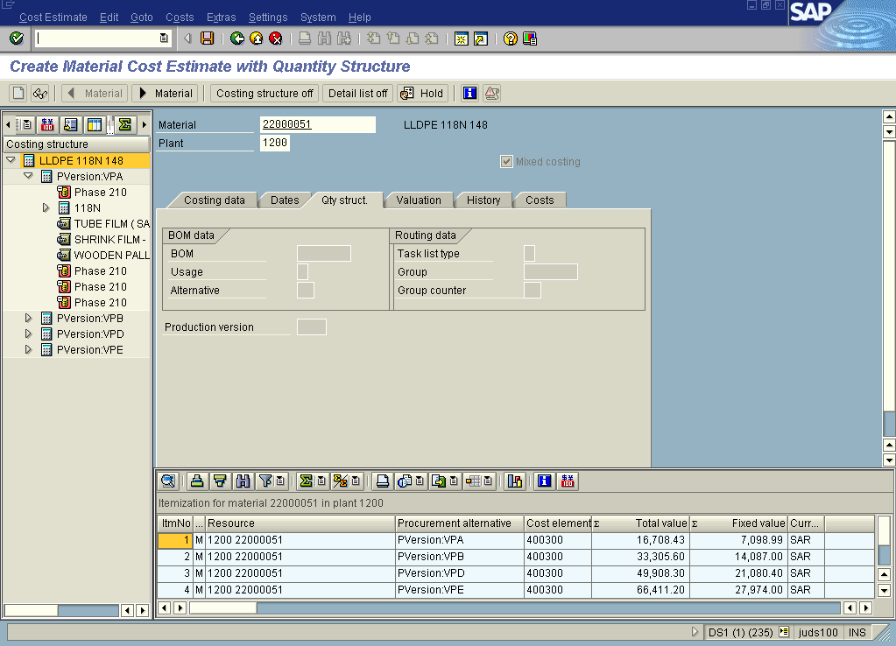

9. Click the Valuation tab button.

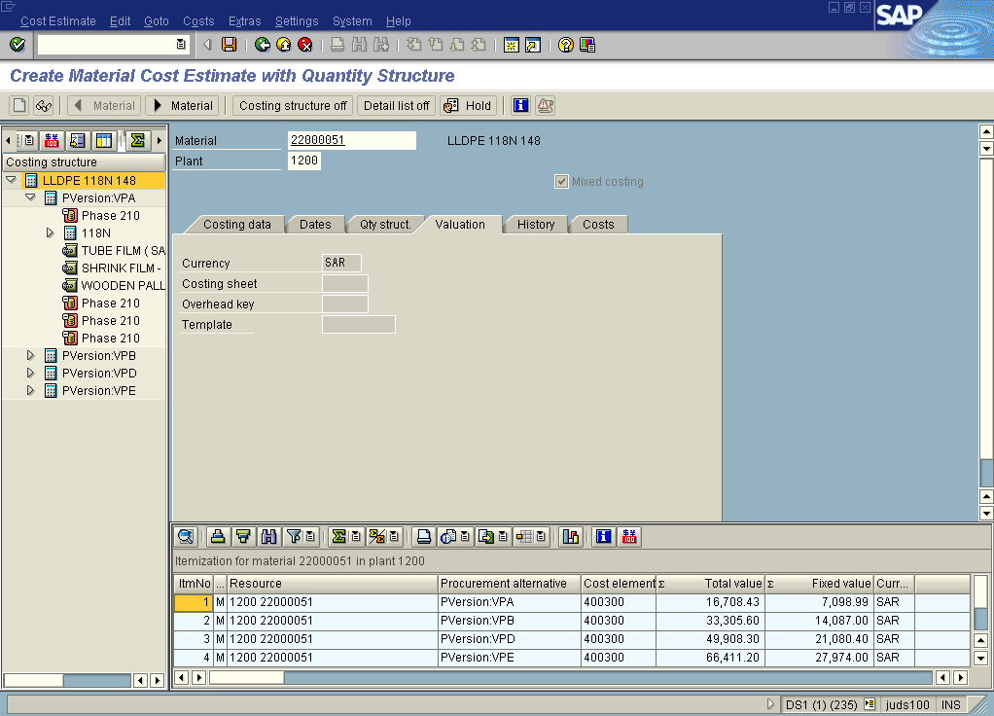

10. Click the History tab button.

11. Click the Costs tab button.

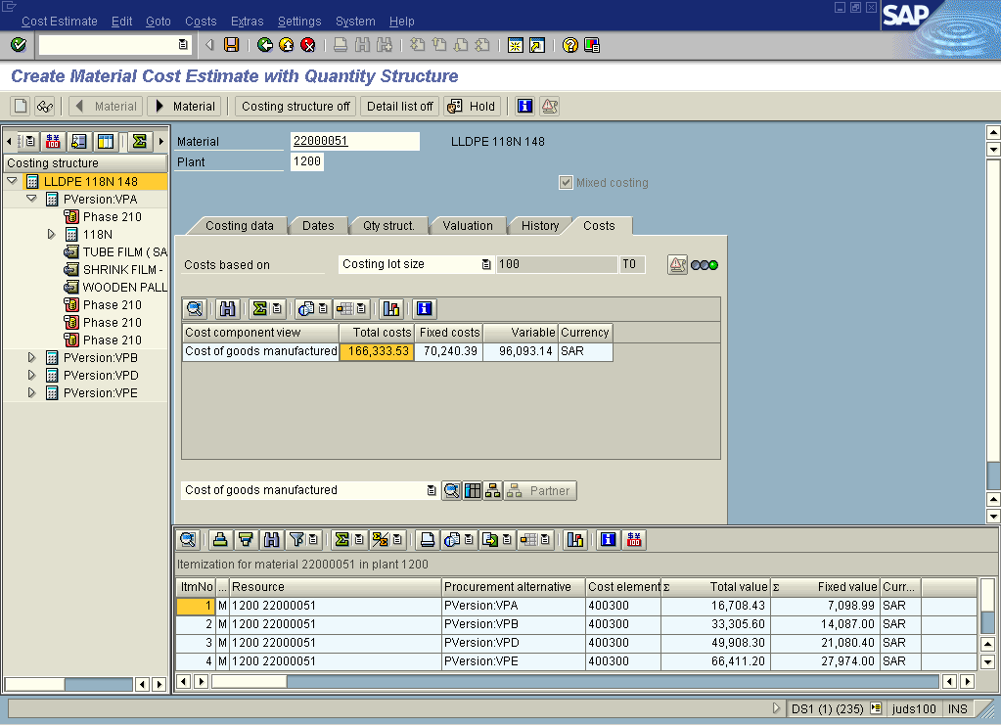

12. Click the List button.

Display Material Cost Estimate with Quantity Structure

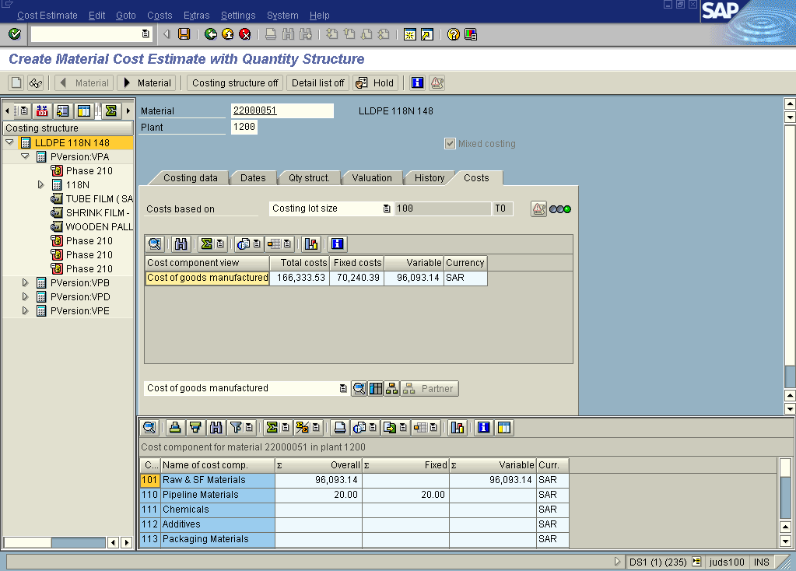

13. Click the Type of Cost Component Split 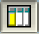 button.

Type of cost component split

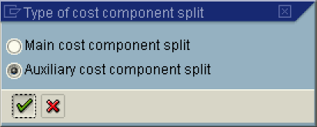

14. Click the Auxiliary cost component split radio button.
15. Click the Continue button.

Display Material Cost Estimate with Quantity Structure

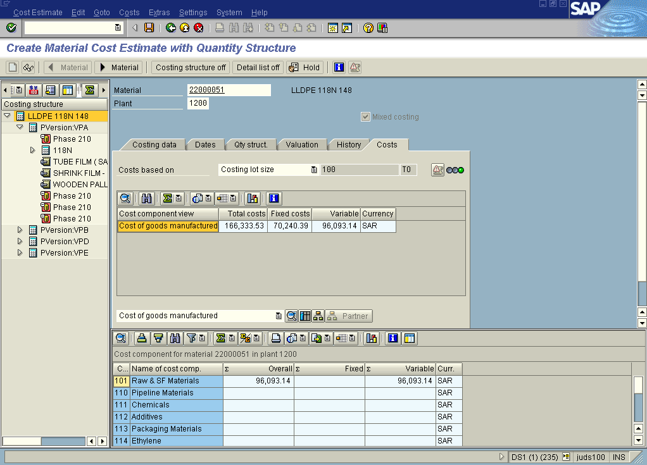

16. Click the Save button.

Display Material Cost Estimate with Quantity Structure

